7.0 Characters and Stories:

For this week’s task, the goal was to create a character and give a character that belonged to somebody else a full arc from beginning to end.

7.1 The character:

The character that was chosen was a character that belonged in the protagonist’s party. Despite the role it had was difficult in comparison to a protagonist. The template for the character was rather simple and easy to work with (as shown in Figure 1.) whereas the other choices that were available were far more complex in areas such as personality and abilities that creating a story around them would take more time, so it was decided that it would be the best choice.

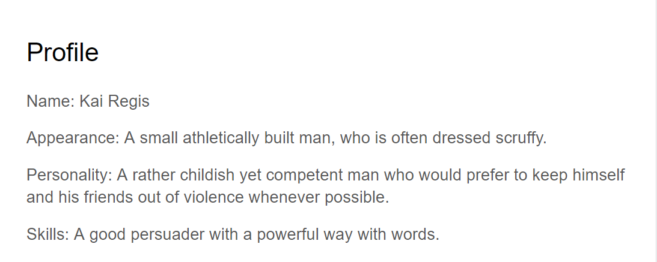

Figure 1. Character Profile.

7.2 The story:

Because of the simplicity of the character, creating a story around them and a protagonist was also easy. Rather than take the view of the protagonist, the story took on the view of the character. It followed the screenwriter’s master chart, but fused certain elements were quickly glossed over.

Following the chart’s structure, the story began with a backstory that led to the main setup of how the two characters would begin their journey. Once that was done the next parts of new opportunities and choices were quickly glossed over to put more effort in creating the growth the characters gained throughout the journey.

It was only until there was a need for substantial character growth that details were added on. Growth was enforced in the middle of the story for the character, but it was then fully completed near the climax when the morale of the group had dropped to the lowest point. At this point, the protagonist was separated from the party, paving way for the character to temporarily take their place.

However despite the growth benefitting the chosen character, the ending reinforced the fact that they are not the protagonist by tearing them out of the climax and returning the protagonist in the scene to finally finish the climax.

7.3 Mechanics:

In terms of mechanics that affect gameplay, skill trees are a simple yet effective way to show progression in both characters and story. Certain skills could be locked behind story progression, prompting the player to continue with the story. Or as the story goes on a new type of skill tree unlocks when the characters learn something new in their journey.

For the story, most characters may get their arcs told through cutscenes. However because there were a small number of characters in the story it could be possible to have a game where players are able to swap between the main protagonist and side character at certain points throughout the story. It also could work when developing both characters as well since it can give opportunities for the players to see different events to happen in different perspectives.

This type of mechanic would be useful to progress both characters along with the story, but it would be at the climax where this would be the most prevalent because it was during the climax that the chosen character took the role of the protagonist temporarily while the actual protagonist was separated. So this would be very effective from a storytelling standpoint.